EXP 9: Design and implement 2-bit half adder using logisim simulator?

**TRUTH TABLE:-**

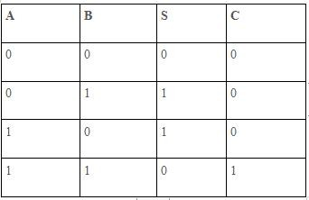

CIRCUIT DIAGRAM:

